CLOUD COMPUTING

**Saif Ur Rehman**

**CS-191098**

**8A**

This is the s3 bucket

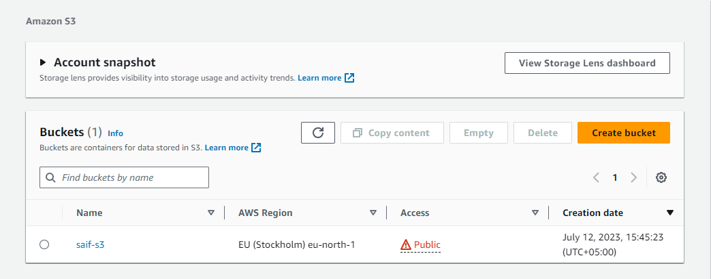

This is inside the created bucket saif-s3

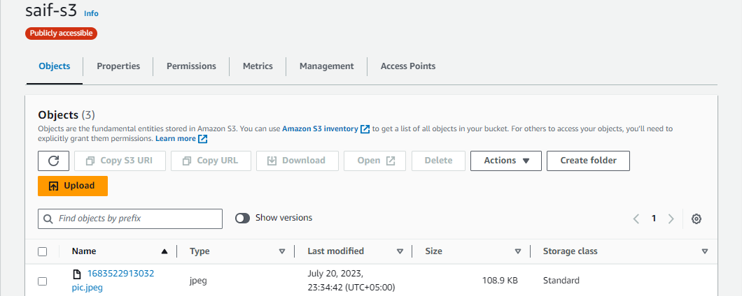

**This is image URL**

<https://saif-s3.s3.eu-north-1.amazonaws.com/1683522913032+pic.jpeg>

This is the EC2 instance

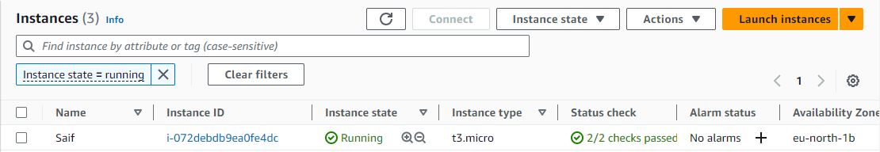

This is inside the Saif instance

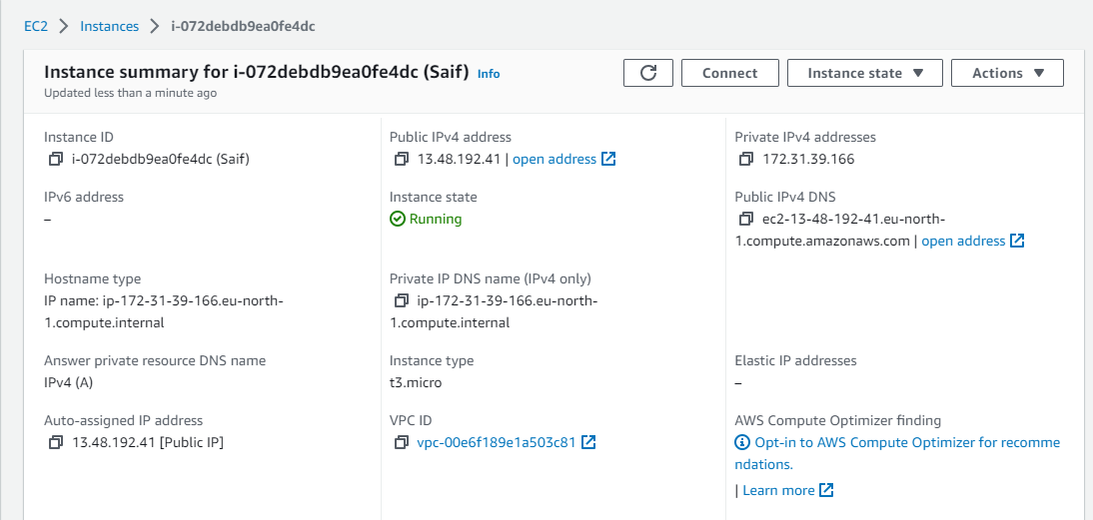

**This is the IPv4 address:** <http://13.48.192.41:8084/>

